MiVAC Chairman’s Report – AGM - 3 August 2021
Welcome
Welcome to all those attending, including Lyn and Peter via links.
This AGM for MiVAC follows on from our September 2019 AGM, and so covers the two year period.
With the delays thanks to COVID, sadly we have had very little activity during this period.
Terry Moore
I ask that we pause for a moment to remember Terry, and the generous contributions he made in Laos – both of his time and financially. He will be missed by us all.
Vietnam
Unfortunately, the number of new COVID cases in Vietnam has recently increased considerably, as shown here:
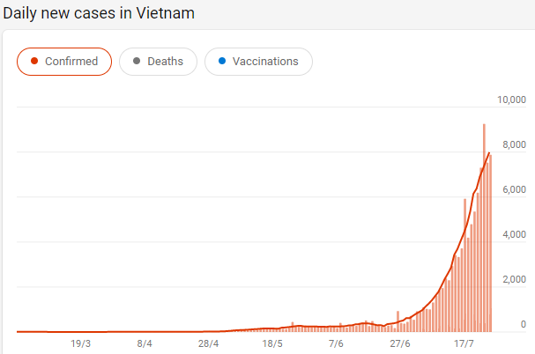
Source: https://www.bing.com/search?q=Coronavirus+map+Vietnam

Clearly, this is not a good time for us to go to Vietnam. We have advised both KCF and DoFA Quang Tri, that we will delay our arrival until at least Feb 2022. This means we will also miss their wet season and their Tet festival.
We applied to COMINGO (the Committee for Foreign Non-Governmental Organisations) in Hanoi for a Certificate of Registration of Operation of FNGO’s in Viet Nam in December last year. They then requested “consularised” documents, which were emailed on 2 April, then updated and couriered on 3 May this year. We understand that our application is progressing, but has not yet been approved. We need the Certificate of Registration of Operation of FNGO’s in Viet Nam in order to commence our work there. Attempts to get a likely approval date have been unsuccessful…
Our Operations Manager will shortly provide a more detailed update on our proposed project work in the Ba Tang community near Khe Sanh.
As you may recall, I submitted a Friendship Grant application to DFAT in Sep 2019 for $60,000 for toilets. Unfortunately we were unsuccessful, as our project ran over 2 years, and DFAT only wanted 1 year projects. Nice if this had been clearer from the start, as a lot of work went into the application!!
GDG has our project in their web page system – J1014N – WASH in Ba Tang, Vietnam. https://globaldevelopmentgroup.org/au/projects/j1014n-ba-tang-wash-vietnam/
Volunteers
Once we have our Certificate of Registration of Operation of FNGO’s in Viet Nam, and COVID is brought under control in Vietnam, we can proceed further with our project planning.
Peter will provide an update on this.
Clearly we will need much of the Administrative and Logistics aspects for living and working around Khe Sanh sorted out too. Peter will coordinate these aspects while he is there.
I am willing to spend say 4 months in Vietnam getting the designs and layouts confirmed, construction materials sourced, and works underway.
Lee Uebergang has offered to follow me for 4 months also, with the assumption that there would be 2 weeks of takeover/handover briefing at the beginning and ending - as part of the 4 month commitment. He hopes to enlist other sappers also.
We also need to contact John Salter to find out how he is, and to see if he would still like to/is able to assist.
We also need to get the word out on the various sapper Facebook pages and other means to seek other volunteers.
Funding
- Members – we have around 550 members on our books, but clearly many of these are inactive. This year I believe we need to update our records, and to actively push for membership renewals, as well as seeking new members. I seek your suggestions on how we can best do this. We may be able to get a free computer system to help manage the member list, or pay a small fee for one?
- We appear to have received little membership funding this last year.
- External funding - Kadoorie was our main external funder in Laos. We now need to seek renewed funding if we wish to work in Vietnam.
- ACNC have a “Registered Charity” symbol that we can use on our stationery, signboards etc. We need to utilise this as recognition that we are registered.
Newsletters
The Board has been very busy in our own personal activities this year, and we have not issued any newsletters for quite some time. I feel we should be sending out newsletters perhaps quarterly once projects are underway. Perhaps our volunteers can submit a short (say 2-3page) newsletter at the end of their time in Vietnam??
IT
Our various types of software and internet programs have successfully managed to confound most of our Board members. However, Peter has achieved progress, and will report on that.
Senator Bilyk
Tasmanian Senator Catrina Bilyk has kindly agreed to be a referee for MiVAC.
We need to work out how we can best utilise her support!
Thank you’s
- Peter Perry – for his drive on things various, including our website, and coordinating first steps in Vietnam
- Lyn Clark – for general assistance
- Merv Hains – for keeping track of our finances, and completing the statements
- Rob Woolley – for general assistance, and arranging this great venue
- All MiVAC members

